**Database and Management System Lab**

NAME: PRIYANSHI VARSHNEY

ROLL NO: R2142230042

SAP_ID: 500119947

BATCH 2

B.TECH CSE, SEM-III

**PROJECT- STUDENT MANAGEMENT SYSTEM**

**PRESENTED TO-** DR. SYED SAJID HUSSAIN

1. CREATING DATABASE

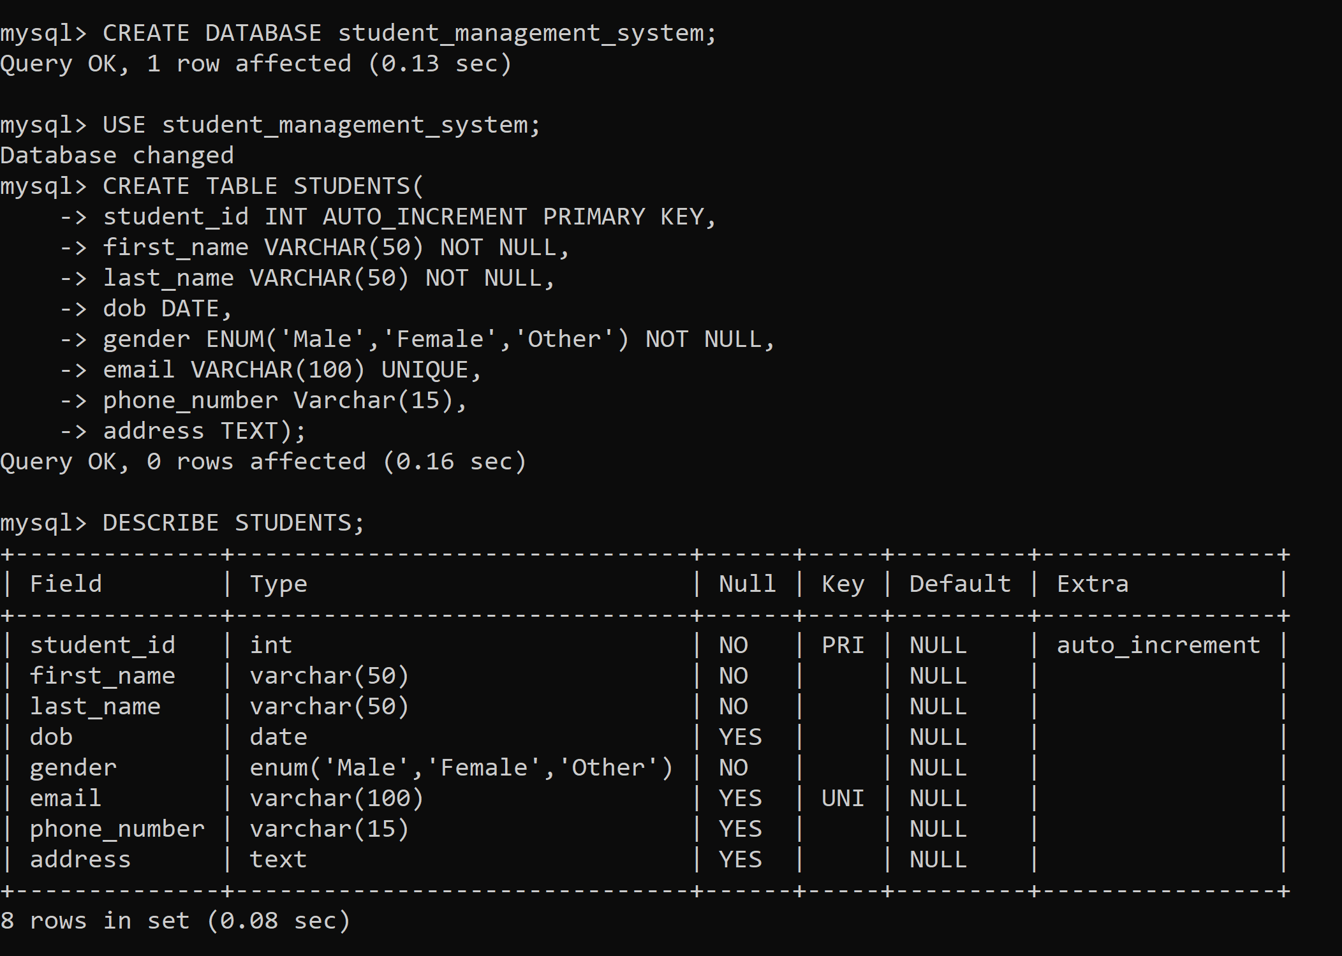

1. CREATING TABLES



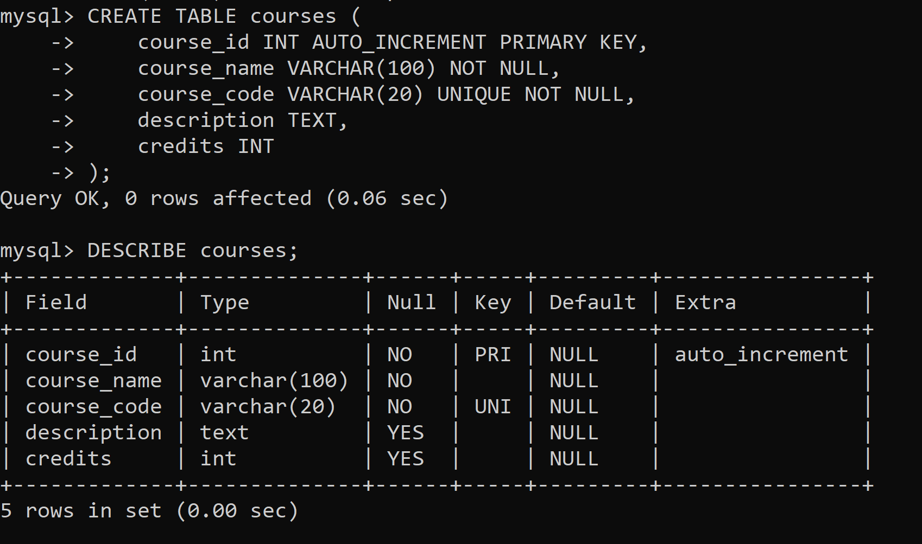

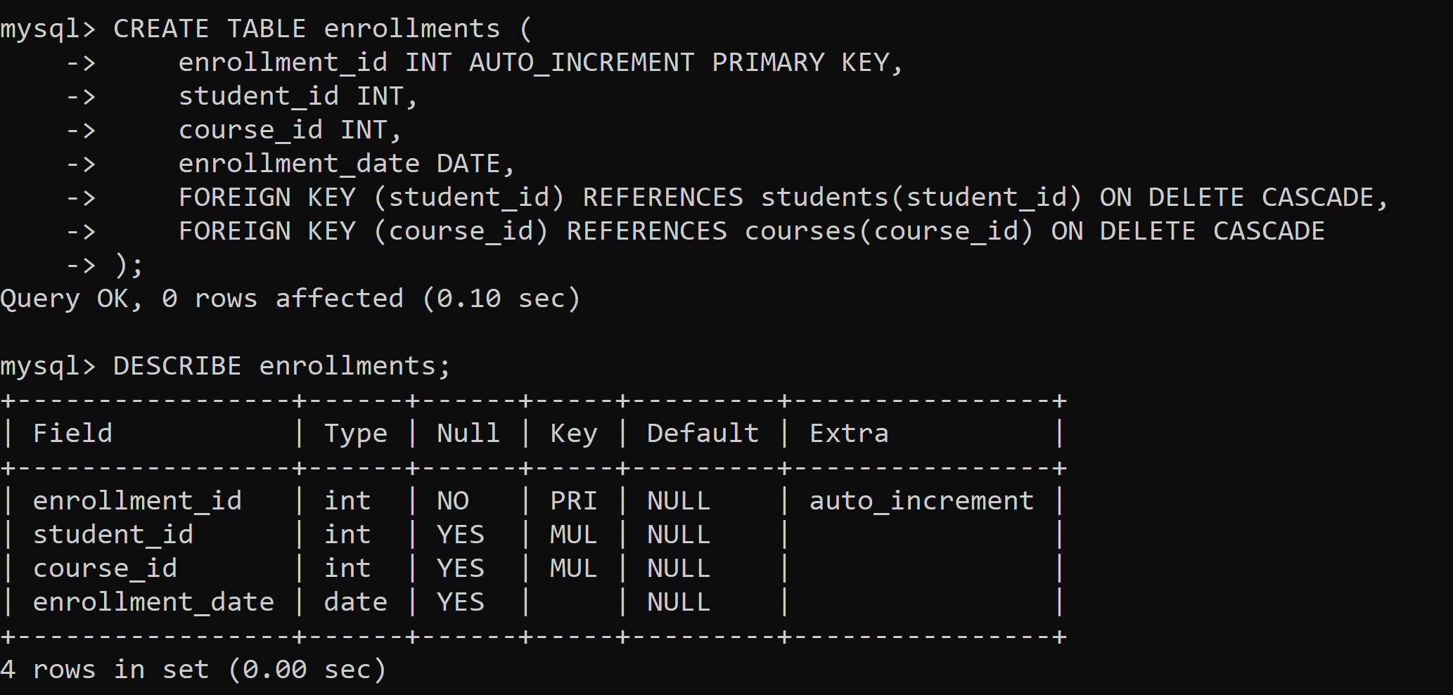

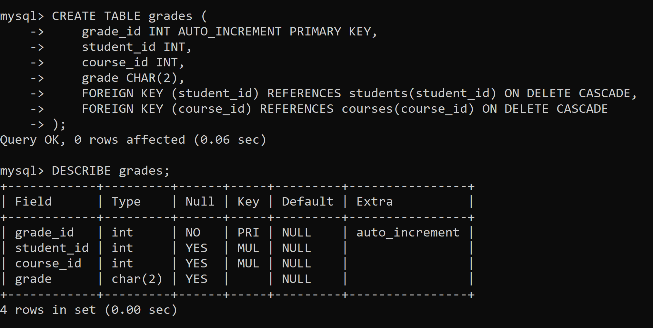

1. INSERTING INTO THE TABLES

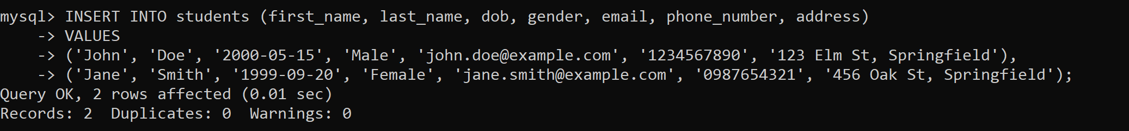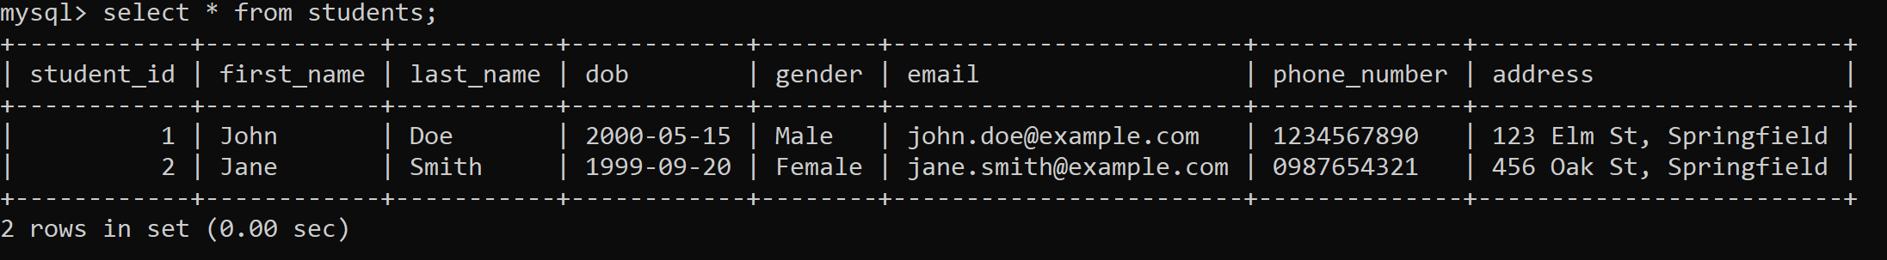

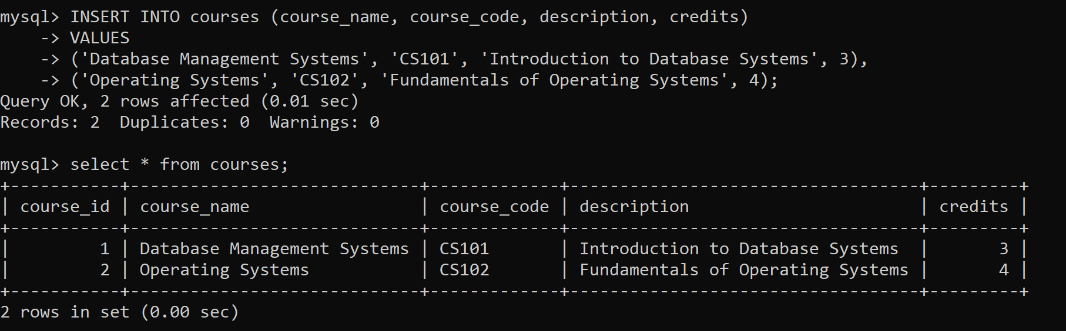

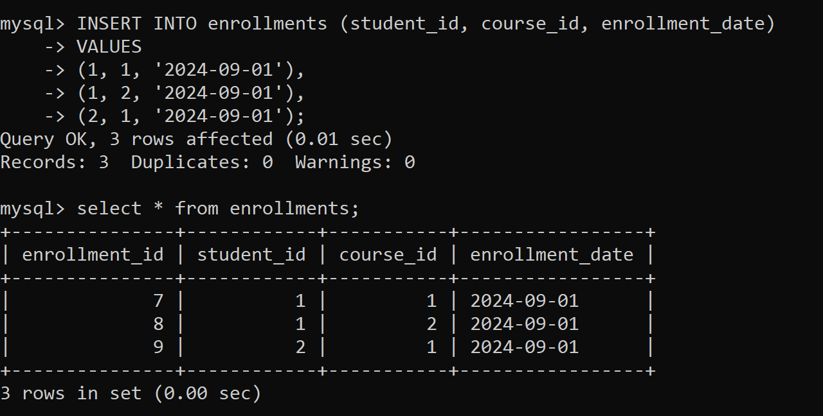

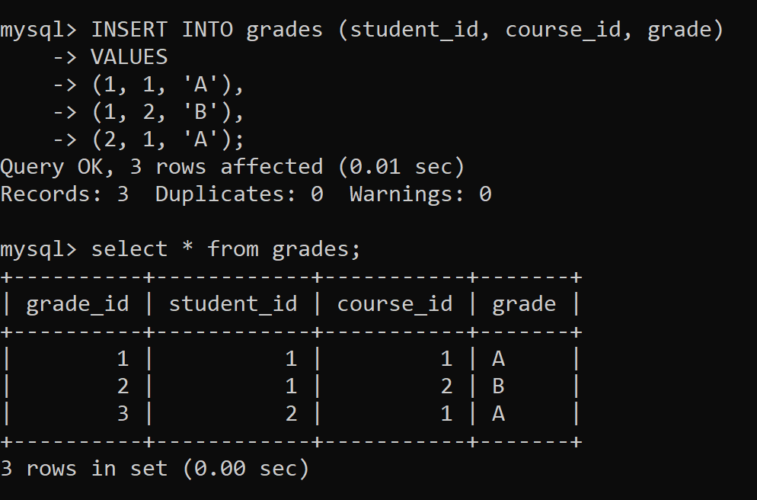

* RETRIEVING ALL ENROLLMENTS (STUDENTS AND THEIR COURSES)

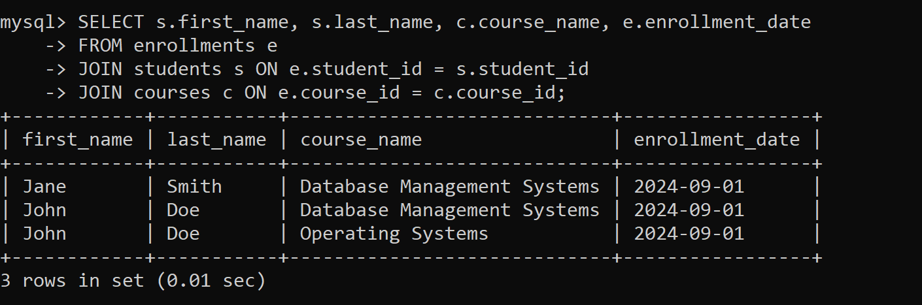

* RETRIEVE GRADES FOR A SPECIFIC STUDENT

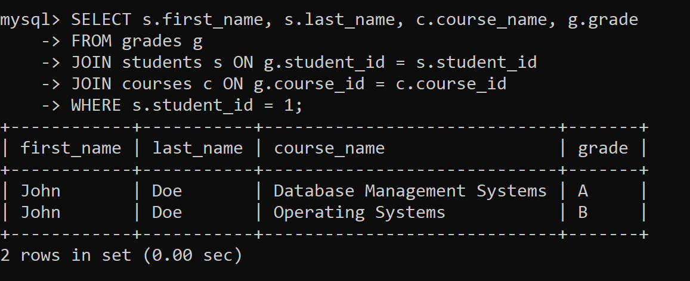

* GET THE AVERAGE GRADE OF A STUDENT

